**Commands Utilities**

1. **Which command is used to know the current working directory?**

The command used to know the current working directory is pwd, which stands for "print working directory”.

1. **How would you find out its contents?**

* To find out the contents of the current working directory we use the command **ls**. This will list the files and directories within the current directory.
* You can use options like **ls -l** for a detailed list or **ls -a** to include hidden files.

1. **Identify the commands with inputs to do the following.**

a. create a directory d1

- mkdir d1

b. create a subdirectory d2 in d1

- mkdir d1/d2

c. change to directory d2

- cd d1/d2

d. create an empty file “f1.txt”

- touch f1.txt

e. display the contents of “f1.txt”

- cat f1.txt

f. view the contents of d1 from current directory d2

- ls ..

**4. Use the ls command with its options. How will you identify directories from the listing?**

ls command is used to list directory contents. It shows files and directories in the current directory. The ls options gives more detailed information.

1. ls-l = provides a long listing format

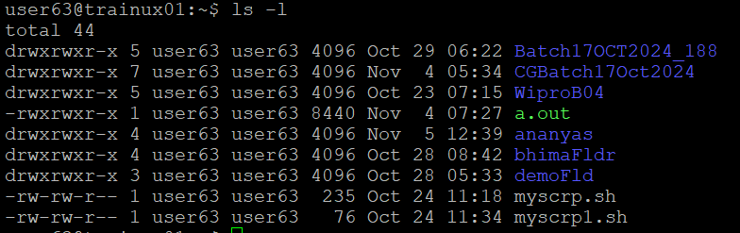

1. ls -a = lists all files,including hidden files



1. ls -A = Similar to -a, but it does not show. and ...



1. ls -i = Displays the inode number for each file or directory.

1. ls -g = displays owner and group information

To identify directories from listing we use ls-d.

**5. Use ls to do the following**

* 1. **List files with single character names.**
* ls? To list files with single character names we can use the wildcard ?, that matches exactly one character .
  1. **List hidden files also. [ Note: Hidden files are files having name started with a “.” ]**
* ls -a
  1. **Suppose there are files tb1.1, tb2.1, tb3.1, …. tb10.1. Write command to list all the files [Hint: use wild card characters]**
* ls tb?.1 tb 10.1

1. **Write the command to list all files in descending order of their size.**

* ls -ls

1. **Suppose there are files temp1, temp2, temp3. Write command to remove the files without listing them explicitly**

* rm temp*

1. **Which command is used to list top few lines in the file?**

* Head -n <number_of_lines> <file_name>

1. **Create a directory “testdir”**

* mkdir testdir

1. **Use cp command to do the following** 
   1. **Copy the file tb1.1 (created above) in the same directory.**

cp tb1.1 tb1_copy.1

* 1. **Write a command to copy all the files i.e tb1.1,tb2.1,tb3.1,…..tb10.1 in a new directory –“new”**

To create a new directory: mkdir-p new.

To copy all the files to the new directory: cp tb*.1 new/

* 1. **Create a subdirectory in new in named“new1”.**

Mkdir -p new/new1

* 1. **Write a command to copy selectively only tb2.1, tb6.1, tb7.1 and tb10.1 in the directory new1.**

cp tb2.1, tb6.1, tb7.1,tb10.1 new/new1

* 1. **Write a command to copy the entire directory “new” to a directory “newprogs”. [Note : use the –R option of “cp” command ]**
* cp -R new newprogs

1. **Find out the difference between** 
   1. **“mv” & “cp”**

The mv command is used to move files or directories from one location to another.

Syntax: mv [OPTION]... SOURCE... DIRECTORY

The cp command is used to copy files or directories from one location to another.

Syntax: cp [OPTION]... SOURCE... DIRECTORY

* 1. **“rm”, “rmdir”**
* The rm command is used to remove files or directories

Syntax: rm [OPTION]... [FILE]...

rm [options] [file or directory]

* The rmdir command is specifically designed to remove empty directories.

Syntax: rmdir [directory]

* 1. **“mkdir” and “mkdir -p”**
* mkdir: create a single new directory at the specified location.

Syntax : mkdir newdir

* mkdir-p: create a new directory and its parent directories

Syntax: mkdir -p [options] directory_path

1. **Use a single command rmdir once to remove “testdir” and all its sub directories and files created above.**

* rm -r testdir

1. **Which command is used to get the manual information of a command?**

* man <command_name>

1. **If you are not able to change to a directory what could be the likely cause?**

* The specified directory may not exists or may not have the necessary permissions to access the directory.

1. **Explain the differences among the following commands:**

a. cd / : Goes to the root directory

b. cd ..: Moves to the parent directory

c. cd : Moves to the user’s home directory

d. cd ../.. : Moves to the grandparent directory